The Annual Quality Assurance Report (AQAR) of the IQAC

All NAAC accredited institutions will submit an annual self-reviewed progress report to NAAC, through its IQAC. The report is to detail the tangible results achieved in key areas, specifically identified by the institutional IQAC at the beginning of the academic year. The AQAR will detail the results of the perspective plan worked out by the IQAC. (Note: The AQAR period would be the Academic Year. For example, July 1, 2012 to June 30, 2013)

Part – A
1. Details of the Institution
SANTAL PARGANA COLLEGE, DUMKA
1.1 Name of the Institution
SONUADANGAL
1.2 Address Line 1
PAKUR ROAD
Address Line 2
DUMKA
City/Town
JHARKHAND
State
814101
Pin Code
spc1954@rediffmail.com
Institution e-mail address
06434-222246
Contact Nos.
DR. GAGAN KUMAR THAKUR
Name of the Head of the Institution:
06434-222246

Tel. No. with STD Code:
9934571516

Mobile:

Name of the IQAC Co-ordinator:
PROF. PRASHANT
9431150079
8789338697
Mobile:
iqacspc1954@gmail.com
IQAC e-mail address:

JHCOGN26496
1.3 NAAC Track ID (For ex. MHCOGN 18879)
EC(SC)/22/A&A/32.1
1.4 NAAC Executive Committee No. & Date:
(For Example EC/32/A&A/143 dated 3-5-2004.
This EC no. is available in the right corner- bottom
of your institution’s Accreditation Certificate)

www.spcollegedumka.com
1.5 Website address:
www.spcollegedumka.com/NAAC/AQAR2017-18.doc
Web-link of the AQAR:
For ex. http://www.ladykeanecollege.edu.in/AQAR2012-13.doc
1.6 Accreditation Details
Sl. No. | Cycle | Grade | CGPA | Year of Accreditation | Validity Period
1 | 1st Cycle | B | 2.25 | 2017 | UPTO 21.02.2022
2 | 2nd Cycle | - | - | - | -
3 | 3rd Cycle | - | - | - | -
4 | 4th Cycle | - | - | - | -

1.7 Date of Establishment of IQAC : DD/MM/YYYY
21.05.2014

2017-18
1.8 AQAR for the year (for example 2010-11)

1.9 Details of the previous year’s AQAR submitted to NAAC after the latest Assessment and Accreditation by NAAC ((for example AQAR 2010-11submitted to NAAC on 12-10-2011)
- AQAR __________________NOT APPLICABLE______ (DD/MM/YYYY)
- AQAR__________________ ________________________ (DD/MM/YYYY)
- AQAR__________________ ________________________ (DD/MM/YYYY)
- AQAR__________________ ________________________ (DD/MM/YYYY)
1.10 Institutional Status
ŀ

University State Central Deemed Private

Affiliated College Yes No
ŀ

Constituent College Yes No
ŀ

ŀ

Autonomous college of UGC Yes No

ŀ

Regulatory Agency approved Institution Yes No
(eg. AICTE, BCI, MCI, PCI, NCI)
ŀ

Type of Institution Co-education Men Women

ŀ

Urban Rural Tribal
ŀ

ŀ

ŀ

Financial Status Grant-in-aid UGC 2(f) UGC 12B
ŀ

Grant-in-aid + Self Financing Totally Self-financing

1.11 Type of Faculty/Programme
ŀ

ŀ

ŀ

ŀ

ŀ

Arts Science Commerce Law PEI (Phys Edu)

ŀ

TEI (Edu) Engineering Health Science Management

Others (Specify)
BBA/BCA
SIDO KANHU MURMU UNIVERSITY, DUMKA
1.12 Name of the Affiliating University (for the Colleges)

1.13 Special status conferred by Central/ State Government-- UGC/CSIR/DST/DBT/ICMR etc
NA
Autonomy by State/Central Govt. / University
NA

University with Potential for Excellence UGC-CPE
NA

NA

NA

DST Star Scheme UGC-CE
NA

NA

UGC-Special Assistance Programme DST-FIST
NA

PREMIER COLLEGE
UGC-Innovative PG programmes Any other (Specify)
NA

UGC-COP Programmes
2. IQAC Composition and Activities
07
2.1 No. of Teachers
01
2.2 No. of Administrative/Technical staff
00
2.3 No. of students
2.4 No. of Management representatives
03
00
2.5 No. of Alumni
2. 6 No. of any other stakeholder and
01
community representatives
01
2.7 No. of Employers/ Industrialists

00
2.8 No. of other External Experts
2.9 Total No. of members
10
2.10 No. of IQAC meetings held - 03 (THREE)

2.11 No. of meetings with various stakeholders: No. Faculty

03

01

Non-Teaching Staff Students Alumni Others

ŀ

2.12 Has IQAC received any funding from UGC during the year? Yes No

If yes, mention the amount
2.13 Seminars and Conferences (only quality related)
(i) No. of Seminars/Conferences/ Workshops/Symposia organized by the IQAC
-
-

-

-

-

Total Nos. International National State Institution Level
-

(ii) Themes
2.14 Significant Activities and contributions made by IQAC
*ACADEMIC & RESEARCH ACTIVITIES IMPROVED
*DIGITALIZATION OF THE EXAMINATIONS
*CLEANLINESS DRIVE
*ENVIRONMENTAL AWARENESS
*WOMEN CELL

2.15 Plan of Action by IQAC/Outcome
The plan of action chalked out by the IQAC in the beginning of the year towards quality
enhancement and the outcome achieved by the end of the year *

Plan of Action | Achievements
*Different committees formed.  *Strategy planned  *Digitization (for e-filing, registration, admission, result & notices.  *Asset creation (purchase of colour printer)  *Social responsibility (through Santal Culture & Heritage Cell awareness is being created  *Gender sensitization (workshop by women cell.  *Environmental awareness.  *Tree plantation.  *Facilities for differently abled (build ramps)  *Sharing information about different welfare scheme.  *Meeting with stakeholders planned.  *Feedback from parents & students to be taken together. | Not so far
* Attach the Academic Calendar of the year as Annexure.

ŀ

2.15 Whether the AQAR was placed in statutory body Yes No

Management Syndicate Any other body
Provide the details of the action taken
N/A

Part – B
Criterion – I
1. Curricular Aspects
1.1 Details about Academic Programmes
Level of the Programme | Number of existing Programmes | Number of programmes added during the year | Number of self-financing programmes | Number of value added / Career Oriented programmes
PhD | 18 DEPTS. | - | - | -
PG | 06 DEPTS. | - | - | -
UG | 18 DEPTS. | - | BCA,B.ED., L.LB. | -
PG Diploma | - | - | - | -
Advanced Diploma | - | - | - | -
Diploma | - | - | - | -
Certificate | - | - | - | -
Others | - | - | - | -
Total | 42 | - |  | -

Interdisciplinary | - | - | - | -
Innovative | - | - | - | -

1.2 (i) Flexibility of the Curriculum: CBCS/Core/Elective option / Open options
(ii) Pattern of programmes:
Pattern | Number of programmes
Semester | 34
Trimester | -
Annual | -

-
-

-

-

1.3 Feedback from stakeholders* Alumni Parents Employers Students
(On all aspects)
-

-

-

Mode of feedback : Online Manual Co-operating schools (for PEI)
*Please provide an analysis of the feedback in the Annexure

1.4 Whether there is any revision/update of regulation or syllabi, if yes, mention their salient aspects.
YES, AS PER SKM UNIVERSITY INITIATIVE AT UNIVERSITY LEVEL.

1.5 Any new Department/Centre introduced during the year. If yes, give details.
NO

Criterion – II
2. Teaching, Learning and Evaluation
2.1 Total No. of permanent faculty
Total | Asst. Professors | Associate Professors | Professors | Others
39 | 34 | 05 | 00 | 00

2.2 No. of permanent faculty with Ph.D.
27
2.3 No. of Faculty Positions Recruited (R) and Vacant (V) during the year
Asst. Professors |  | Associate Professors |  | Professors |  | Others |  | Total
R | V | R | V | R | V | R | V | R | V
34 | 62 | 05 | 00 | 00 | 00 | 00 | 00 | 39 | 62

04
03
18
2.4 No. of Guest and Visiting faculty and Temporary faculty

2.5 Faculty participation in conferences and symposia:

No. of Faculty | International level | National level | State level
Attended Seminars/ Workshops | 09 | 19 | -
Presented papers | 09 | 19 | -
Resource Persons | - | - | 02

2.6 Innovative processes adopted by the institution in Teaching and Learning:
Teaching aids are being used in the form of smart classes, show off video classes, remedial classes, orientation, special classes, continuous evaluation and feedback from students and guardians, preparing students for group discussion and oral presentation.

2.7 Total No. of actual teaching days
220
during this academic year
2.8 Examination/ Evaluation Reforms initiated by
BAR CODING
the Institution (for example: Open Book Examination, Bar Coding,
Double Valuation, Photocopy, Online Multiple Choice Questions)

15

2.9 No. of faculty members involved in curriculum
restructuring/revision/syllabus development
as member of Board of Study/Faculty/Curriculum Development workshop

75%
2.10 Average percentage of attendance of students

2.11 Course/Programme wise distribution of pass percentage :

Title of the Programme | Total no. of students appeared | Division
Title of the Programme | Total no. of students appeared | Distinction % | I % | II % | III % | Pass %
B.A.(H)-III | 702 | 02 (00.28%) | 157(22.36) | 384(54.70) | - | -
B.SC.(H)-III | 231 | 25 (10.82%) | 192(83.11) | 28(12.12) | - | -
B.COM.(H)-III | 41 | - | 14(34.14) | 24(58.53) | - | -
B.A.(GEN)-III | 04 | - | - | 01 | 03 | -

2.12 How does IQAC Contribute/Monitor/Evaluate the Teaching & Learning processes:
i. By way of direction and circulars from time to time
ii. Supporting and provind digitazation of general section, accounts section and examination department.
iii. By way of interacting with stackeholders through organization of seminars on different occasions.
iv. By way ensuring extra curricular activities.
v. By way of awareness on health care, gender sensitization, environmnet, cleaniness drive and computer literacy.

2.13 Initiatives undertaken towards faculty development
Faculty / Staff Development Programmes | Number of faculty  benefitted
Refresher courses | 08
UGC – Faculty Improvement Programme | -
HRD programmes | -
Orientation programmes | 02
Faculty exchange programme | -
Staff training conducted by the university | -
Staff training conducted by other institutions | -
Summer / Winter schools, Workshops, etc. | 01
Others | -

2.14 Details of Administrative and Technical staff
Category | Number of Permanent  Employees | Number of Vacant  Positions | Number of permanent positions filled during the Year | Number of positions filled temporarily
Administrative Staff | 31 | 33 | 00 | 00
Technical Staff | 00 | 00 | 00 | 00

Criterion – III
3. Research, Consultancy and Extension
3.1 Initiatives of the IQAC in Sensitizing/Promoting Research Climate in the institution
- Decision was taken to invite scholars for workshop on writing for project and for publication.
- Committee for research and publication was formed.

3.2 Details regarding major projects
 | Completed | Ongoing | Sanctioned | Submitted
Number | 00 | 00 | 00 | 00
Outlay in Rs. Lakhs | 00 | 00 | 00 | 00

3.3 Details regarding minor projects
 | Completed | Ongoing | Sanctioned | Submitted
Number | 01 | 03 | 03 | 01
Outlay in Rs. Lakhs | - | - | 2,00,000.00 | -

3.4 Details on research publications
 | International | National | Others
Peer Review Journals | 08 | 07 | -
Non-Peer Review Journals | 05 | 14 | -
e-Journals | - | - | -
Conference proceedings | 02 | - | -

3.5 Details on Impact factor of publications:
1-3
1.5
-
03
Range Average h-index Nos. in SCOPUS

3.6 Research funds sanctioned and received from various funding agencies, industry and other organisations
Nature of the Project | Duration  Year | Name of the  funding Agency | Total grant  sanctioned | Received
Major projects
Minor Projects | 2016-18  2017-18 | 1.ICSSR, KOLKATA  2.UGC | 1,20,000  55,000 | 1,20,000  55,000
Interdisciplinary Projects
Industry sponsored
Projects sponsored by the University/ College | 2017-18 | 1.S.K.M.U., DUMKA | 25,000 | 25,000
Students research projects
(other than compulsory by the University)
Any other(Specify)
Total |  |  | 2,00,000 | 2,00,000

3.7 No. of books published i) With ISBN No. Chapters in Edited Books
01
01
00
ii) Without ISBN No.
3.8 No. of University Departments receiving funds from
N/A
N/A
N/A
UGC-SAP CAS DST-FIST
N/A
N/A
DPE DBT Scheme/funds
3.9 For colleges Autonomy CPE DBT Star Scheme

INSPIRE CE Any Other (specify)
PREMIER COLLEGE (FUND TO BE RECEIVED)

3.10 Revenue generated through consultancy
N/A
Level | International | National | State | University | College
Number |  |  | 01
Sponsoring agencies |  |  | Adivasi Hul Baisi
3.11 No. of conferences
organized by the Institution

02
3.12 No. of faculty served as experts, chairpersons or resource persons
00
01

00

3.13 No. of collaborations International National Any other
00

3.14 No. of linkages created during this year
3.15 Total budget for research for current year in lakhs :
UGC/ICSSR
SKMU, Dumka
From Funding agency From Management of University/College
Total
2,00,000

3.16 No. of patents received this year
Type of Patent |  | Number
National | Applied | N/A
National | Granted | N/A
International | Applied | N/A
International | Granted | N/A
Commercialised | Applied | N/A
Commercialised | Granted | N/A

3.17 No. of research awards/ recognitions received by faculty and research fellows
Of the institute in the year
Total | International | National | State | University | Dist | College
03 | 01 | 02 | 00 | 00 | 00 | 00

3.18 No. of faculty from the Institution
11
who are Ph. D. Guides
and students registered under them
18

3.19 No. of Ph.D. awarded by faculty from the Institution
12

3.20 No. of Research scholars receiving the Fellowships (Newly enrolled + existing ones)
04

JRF SRF Project Fellows Any other

3.21 No. of students Participated in NSS events:
50
20
University level State level
National level International level
20
01
3.22 No. of students participated in NCC events:
00

00

University level State level
National level International level
00

00

3.23 No. of Awards won in NSS:
00

University level State level
01
National level International level
00

01
3.24 No. of Awards won in NCC:
University level State level
00

00

National level International level
00

00

3.25 No. of Extension activities organized
00
00
University forum College forum
01
10

NCC NSS Any other
3.26 Major Activities during the year in the sphere of extension activities and Institutional Social Responsibility
- LoPNrk vfHk;ku] o`{kkjksi.k] jDrnku

Criterion – IV
4. Infrastructure and Learning Resources
4.1 Details of increase in infrastructure facilities:
Facilities | Existing | Newly created | Source of Fund | Total
Campus area | 37 ACRES | - | - | -
Class rooms | 14 | - | - | -
Laboratories | 06 | - | - | -
Seminar Halls | 01 | - | - | -
No. of important equipments purchased (≥ 1-0 lakh) during the current year. | - | - | - | -
Value of the equipment purchased during the year (Rs. in Lakhs) | - | - | - | -
Others | - | - | - | -

4.2 Computerization of administration and library
*Admission, registration, examinations computerized
*Smart boards partly installed
*Library automation improved

4.3 Library services:
 | Existing |  | Newly added |  | Total
 | No. | Value | No. | Value | No. | Value
Text Books | 43418 | - | 2744 | 1683183 | 46162 | -
Reference Books | 851 | - | 67 | 39712 | 918 | -
e-Books | - | - | - | - | - | -
Journals | 4941 | 46072 | - | - | 4941 | 46072
e-Journals | - | - | - | - | - | -
Digital Database | - | - | - | - | - | -
CD & Video | - | - | - | - | - | -
Others (specify) | - | - | - | - | - | -

4.4 Technology up gradation (overall)
 | Total Computers | Computer Labs | Internet | Browsing Centres | Computer Centres | Office | Depart-ments | Others
Existing | 30 | 01 | 04 | - | - | - | 1 | -
Added | 05 | - | - | - | - | - | - | -
Total | 35 | 01 | 04 | - | - | - | 1 | -

4.5 Computer, Internet access, training to teachers and students and any other programme for technology
upgradation (Networking, e-Governance etc.)
Computer training programme was held for teachers and non-teaching staff of the college by the college administration.

4.6 Amount spent on maintenance in lakhs :

i) ICT
638084
ii) Campus Infrastructure and facilities
2501901
iii) Equipments
586698
iv) Others

3726683
Total :

Criterion – V
5. Student Support and Progression
5.1 Contribution of IQAC in enhancing awareness about Student Support Services
*Orientation of d-1 students
*Counselling of d-1 students
*Women cell

5.2 Efforts made by the institution for tracking the progression
Time to time updation of bio-data of teachers of the various departments.

5.3 (a) Total Number of students
UG | PG | Ph. D. | Others
3221 | 11 | 00

(b) No. of students outside the state
-
-
(c) No. of international students

Men Women
No | %
- | -
No | %
- | -
Last Year |  |  |  |  |  | This Year
General | SC | ST | OBC | Physically Challenged | Total | General | SC | ST | OBC | Physically Challenged | Total
1408 | 238 | 1370 | 400 |  | 3416 | - | - | - | - | - | -
Demand ratio ~1:2 Dropout % =~15.14%
5.4 Details of student support mechanism for coaching for competitive examinations (If any)
N/A

-
No. of students beneficiaries

5.5 No. of students qualified in these examinations
4

-

-

-

NET SET/SLET GATE CAT
IAS/IPS etc State PSC UPSC Others
-

-

-

-

5.6 Details of student counselling and career guidance
N/A for the session 2017-18.

-
No. of students benefitted

5.7 Details of campus placement
On campus |  |  | Off Campus
Number of Organizations Visited | Number of Students Participated | Number of Students Placed | Number of Students Placed
~20 | ~1000 | ~200 | -

5.8 Details of gender sensitization programmes
Programmes of women cell being held periodically.

5.9 Students Activities
5.9.1 No. of students participated in Sports, Games and other events
62
-
-

State/ University level National level International level

No. of students participated in cultural events
18
-

-

State/ University level National level International level

5.9.2 No. of medals /awards won by students in Sports, Games and other events
-

-

12
Sports: State/ University level National level International level
06
-

-

Cultural: State/ University level National level International level

5.10 Scholarships and Financial Support
 | Number of  students | Amount
Financial support from institution | N/A | N/A
Financial support from government | N/A | N/A
Financial support from other sources | N/A | N/A
Number of students who received International/ National recognitions | N/A | N/A

5.11 Student organised / initiatives
-
-

-

Fairs : State/ University level National level International level
-

-

-

Exhibition: State/ University level National level International level
-

5.12 No. of social initiatives undertaken by the students

5.13 Major grievances of students (if any) redressed: New male and female lavatory constructed in the campus. Repairing work of boy’s and girl’s common room in progress. The floor of the teachers’ staff room has been reconstructed for the benefit of teachers and staff as well.

Criterion – VI
6. Governance, Leadership and Management
6.1 State the Vision and Mission of the institution
The college is committed to creating Quality Manpower through excellence and multi-skilled training of students. In its vision submitted to HRD, Govt. Of Jharkhand for justifying Premier status of the college. We have proposed establishment of Community college within the college which will facilitate teaching and training of otherwise not very academically competent students to be developed as multi skilled force. It will also address the problem of migration of youth from Santal Pargana in huge number. For those, who are academically sound and fit will be exposed of carrying research, publication, patenting, consultancy and social leadership. To achieve all this focus has been given to character building through social commitment and Personality Development through specific workshops and counselling conducted by the Career Guidance and Counselling Cell headed by a faculty of Psychology department. Recently special training in ICT was conducted to update the faculty, Administrative members and students in application of computers.

6.2 Does the Institution has a management Information System
Yes, the college has begun its Digital portal to document and share its various academic, administrative, extracurricular and extension services activities. We are also trying to prepare student database with respect to their family, educational, social and aptitude related facts. Orientation of new students is being done in some departments.

6.3 Quality improvement strategies adopted by the institution for each of the following:
6.3.1 Curriculum Development
Our Faculty members are involved in Curriculum design, revision and orientation of students and teachers with respect to changes made thereafter. Workload of teachers as per UGC norms of Minimum Standard of Instruction for Teaching is being prepared which will be enforced after consultation with Staff Council.

6.3.2 Teaching and Learning
We have highly qualified Faculty who have been awarded Fulbright fellowship, Charles Wallace Fellowship, Membership on Editorial Board of International science journals, proposal for writing story and screenplay for films. Many of our faculty members have contributed to academics through National and International Seminars, conferences and publications. The NAAC Peer team headed by Prof. And VC Dr. Prem Sharda has appreciated the quality of Faculty (Copy of NAAC recommendation attached... annexure-i)

6.3.3 Examination and Evaluation
Following the CBCS system our Examination Evaluation system is at par with national parameters. The Examinations department has successfully and smoothly conducted fair Examinations and has helped the university revive faith in. Timely conduct and publication if results. We follow continuous evaluation system with proper feedback and remedial classes afterwards. Example of standard conduct of examination can be viewed in the photo clip...(Photo clip attached... annexure-ii).

6.3.4 Research and Development
The college is trying to focus on this otherwise not very strong point, though many faculty members are pursuing individually on their own. Some Minor Research projects have been bagged by Psychology, Santali and History department faculty members and one proposal for writing story and screenplay for films has also been received by English department. IQAC has been asked to organize workshops and interdepartmental seminars to achieve this goal. We expect fresh activities in coming months.

6.3.5 Library, ICT and physical infrastructure / instrumentation
Old classics, Encyclopedia, rare MS are in stock. Digitization is in progress, shortage of library science personnel. Computer labs for BCA and for other ICT training. All PG teaching departments have smart boards, LCD projectors in Conference Hall, Zoology Dept. Has well equipped state of art lab with ICT facility. Use of CCTV for campus monitoring, Digital Notice board, Wi-Fi system.

6.3.6 Human Resource Management
Faculty and staff are encouraged to participate in career development, allowed to take part in Orientation, Refresher and Overseas visit, take up consultancy, work as resource persons. Occasionally, programmes are organized to give exposure to best practices.

6.3.7 Faculty and Staff recruitment
College does not have any say in recruitment of Faculty or Grade 3 employees. For part time or contractual appointments it sends it’s recruitment to the University. Normally, selections are done by state government agencies.

6.3.8 Industry Interaction / Collaboration
No major collaboration has taken place, however, for Law, B.Ed. BCA and some scientific exposure we invite guests to give lecture and hold workshops

6.3.9 Admission of Students
Admissions are taken through open advertisement and selections are made as per Government regulations and Roster system. Presently we have a centralized digitalized system of admission which is done online.

Teaching | PF, Insurance, Gratuity
Non teaching | PF, Insurance, Gratuity
Students | Scholarships, Hostels, Stipends, Poor Students Fund, Subsidies

6.4 Welfare schemes for

Not so far
6.5 Total corpus fund generated

ŀ

6.6 Whether annual financial audit has been done Yes No

6.7 Whether Academic and Administrative Audit (AAA) has been done?
Audit Type | External |  | Internal
Audit Type | Yes/No | Agency | Yes/No | Authority
Academic |  |  | NO | Govt.
Administrative |  |  | YES | Govt.

6.8 Does the University/ Autonomous College declares results within 30 days?
ŀ

For UG Programmes Yes No

ŀ

For PG Programmes Yes No

6.9 What efforts are made by the University/ Autonomous College for Examination Reforms?
It is not the concern of our college, however, the University carries reforms from time to time through its authorities e.g. Examinations Board, Syndicate, Academic Council.

6.10 What efforts are made by the University to promote autonomy in the affiliated/constituent colleges?
Not applicable.

6.11 Activities and support from the Alumni Association
Not formed yet.

6.12 Activities and support from the Parent – Teacher Association
Not formed yet.

6.13 Development programmes for support staff
Occasionally orientation programmes are conducted based on needs (if any).

6.14 Initiatives taken by the institution to make the campus eco-friendly
Awareness programmes are organized through lectures, seminars. Large scale tree plantations done. Bill boards are used on Environmental awareness, Tobacco free campus, Noise free atmosphere, Rain water harvesting. Medicinal plants and indigenous Flora are to be planted this Monsoon.

Criterion – VII
7. Innovations and Best Practices
7.1 Innovations introduced during this academic year which have created a positive impact on the
functioning of the institution. Give details.
Digitization of Admission, Registration, Examinations. Wi-Fi campus, CCTV cameras for central monitoring. Frequent talks on topics of contemporary issues. Gender and Margin people empowerment. Ramps for Differently abled. Notifications on Women, Margins and Differently abled for their participation, schemes, awareness by Government and NFOs done regularly. Our Women Cell and Santal Culture and Heritage Cell enthusiastically takes up such issues.

7.2 Provide the Action Taken Report (ATR) based on the plan of action decided upon at the
beginning of the year
Not applicable.

7.3 Give two Best Practices of the institution (please see the format in the NAAC Self-study Manuals)
Digitization, Women Empowerment initiatives and Teacher Learner interactions, Remedial classes and Orientation at time of Admission (Observation of NAAC Peer team on Teacher & Students attached... Annexure-iii).

*Provide the details in annexure (annexure need to be numbered as i, ii,iii)
7.4 Contribution to environmental awareness / protection
In the session 2017-18, on the occasion of World Environment Day (5th June, 2017) plantation was done in the college campus by the students and the teachers.

ŀ

7.5 Whether environmental audit was conducted? Yes No

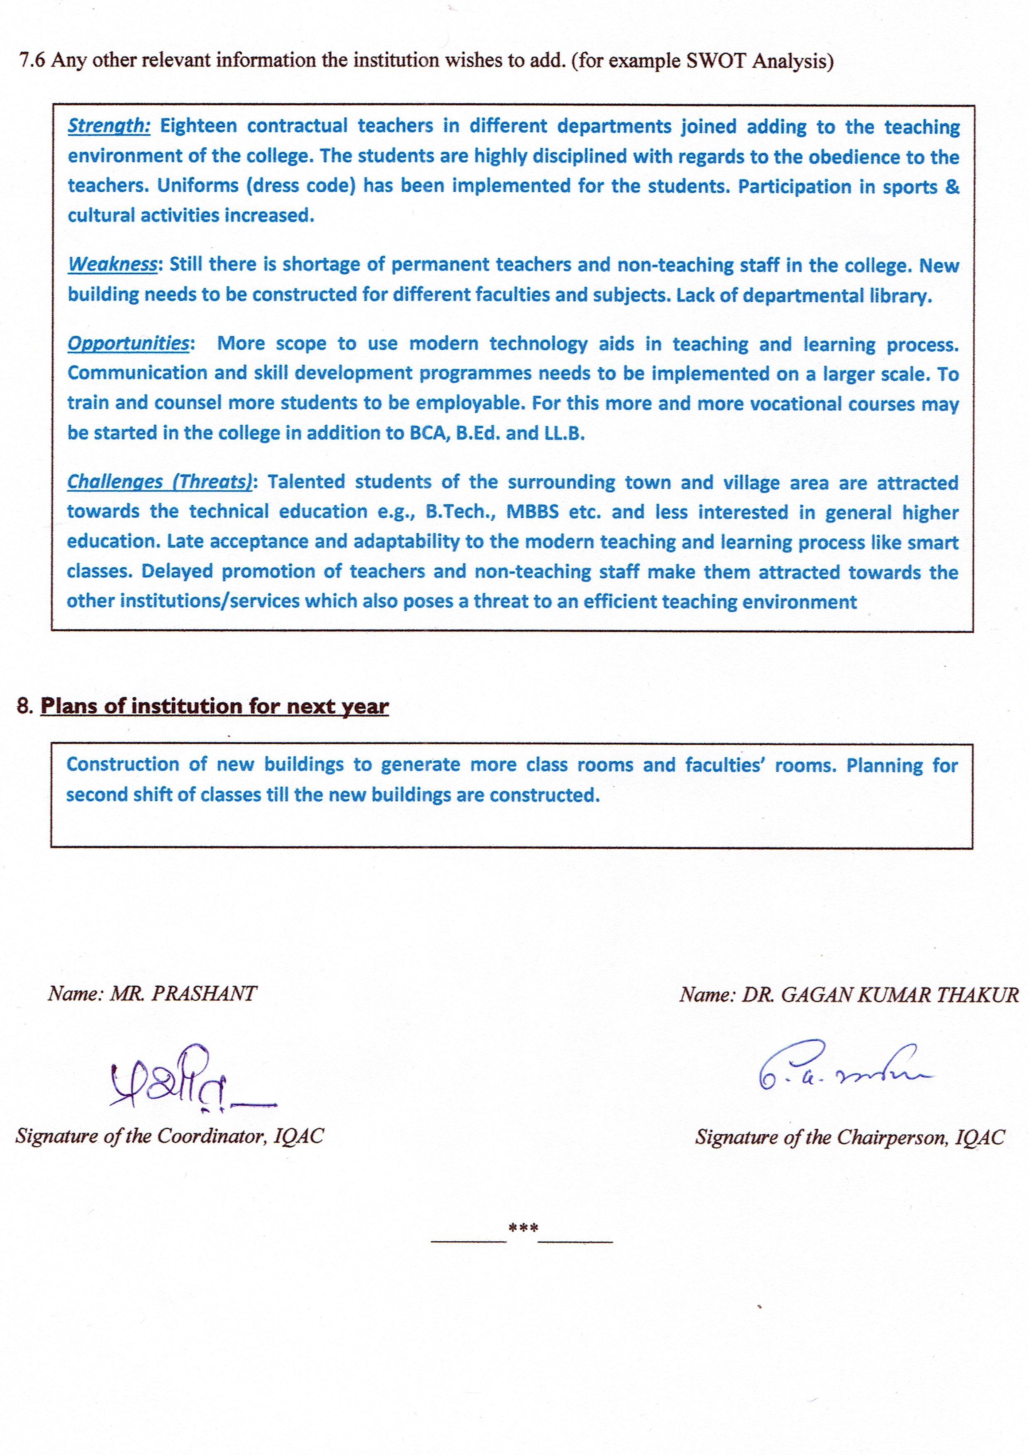
Annexure I
Abbreviations:
CAS - Career Advanced Scheme
CAT - Common Admission Test
CBCS - Choice Based Credit System
CE - Centre for Excellence
COP - Career Oriented Programme
CPE - College with Potential for Excellence
DPE - Department with Potential for Excellence
GATE - Graduate Aptitude Test
NET - National Eligibility Test
PEI - Physical Education Institution
SAP - Special Assistance Programme
SF - Self Financing
SLET - State Level Eligibility Test
TEI - Teacher Education Institution
UPE - University with Potential Excellence
UPSC - Union Public Service Commission

***************

Annexure-i -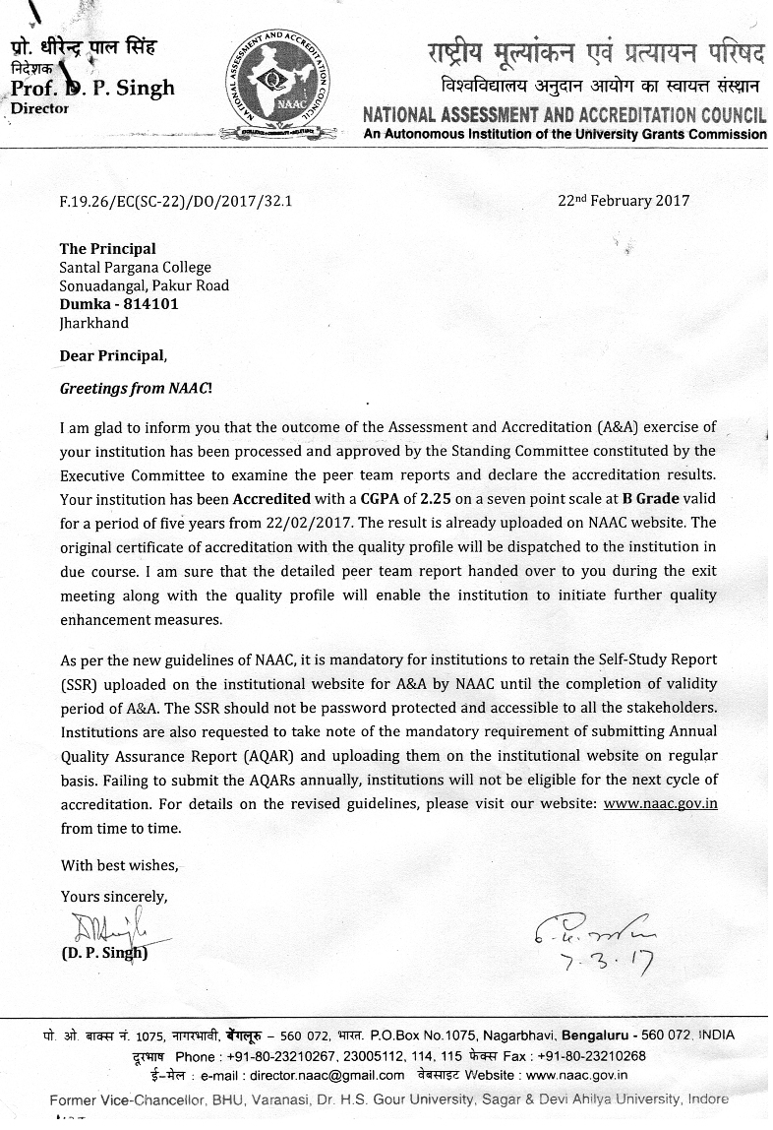

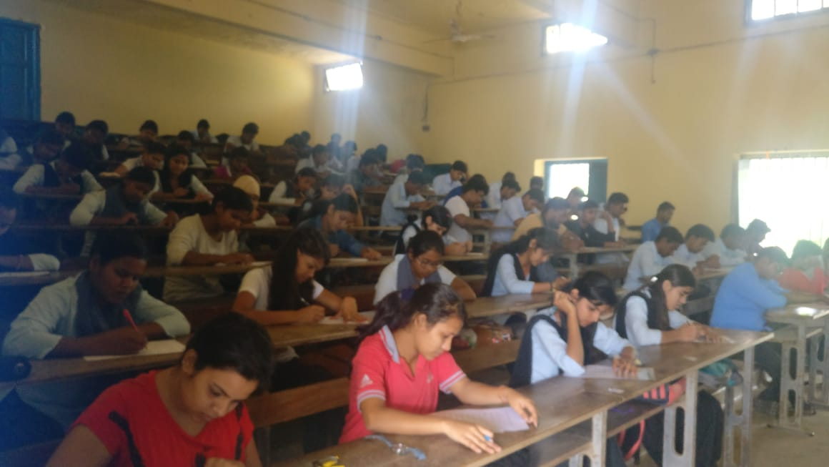
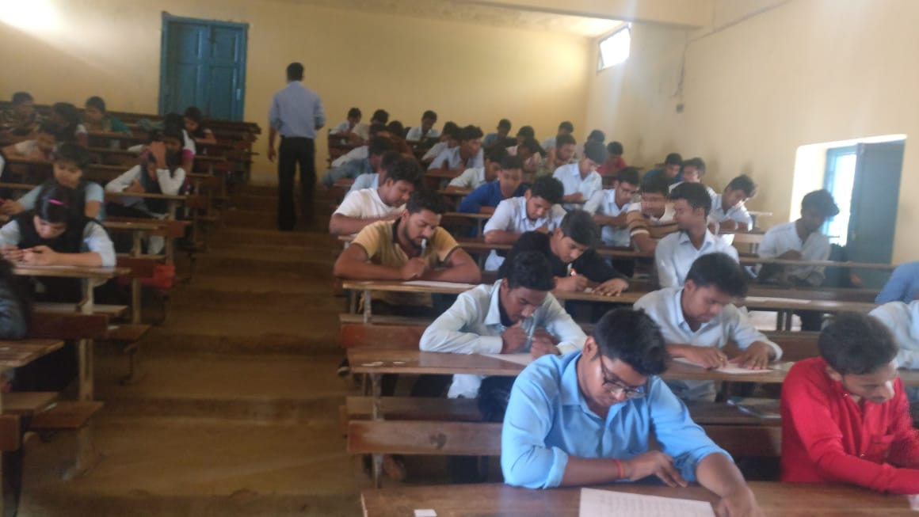
Annexure-ii -
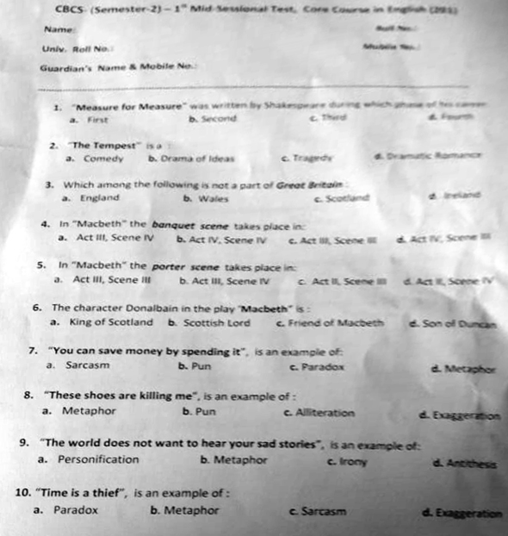

Annexure-iii –


